**Experiment # 7**

Verification of Node Voltage Method using PSPICE

**Objectives:**

* How to calculate node voltages of a circuit.

**Apparatus:**

* Computer with PSPICE installed

**Procedure:**

1. Open schematic program of PSpice
2. Click on the “Get New Part” button on the toolbar
3. Type ‘r’ in the search bar and place the eight resistors on the white sheet
4. Type ‘vdc’ in the search bar and place two of them on the white sheet
5. Type ‘gnd-earth’ and place it on the white sheet
6. Now arrange these components on the white sheet according to the circuit diagram as following
7. After arranging click on simulate button and the following results are generated

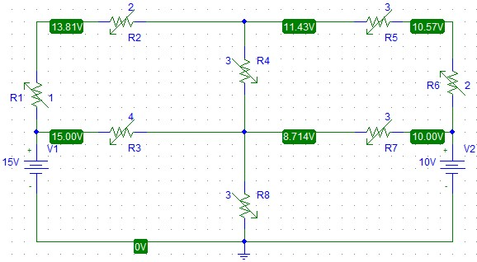

Figure 15 Circuit Diagram

**Note:** Node B is above between R2 and R5 while node D is in the middle between R3 and R7.